Info 5709 Section 005-Project
Fall 2023-1

Data Visualization and Communication

Cyber Security Attacks

  - Hoda Malak
  - ID: 11734843
  - Instructor: Gahangir Hossain
12/14/2023

Introduction:
According to recent data, India has experienced a number of cybersecurity attacks between January 2020 and October 2023. Some of the notable attacks include the SolarWinds attack, which affected multiple government agencies including the United States National Security Agency and the United States Cybersecurity Agency. Other notable attacks include the ransomware attacks targeting Indian companies such as Ambanet and Reliance Industries. Additionally, Indian computers have been targeted by phishing attacks, with cybercriminals attempting to steal sensitive information. It is important for individuals and organizations to take proactive measures to protect themselves from cybersecurity threats. This may include implementing strong passwords, keeping software up-to-date, and using reputable

Dataset:

https://www.kaggle.com/datasets/teamincribo/cyber-security-attacks/data
The dataset is collected from Kaggle. This dataset offers a realistic representation of the history of cyber security attacks among India starting January 2020 till the end October 2023 consisting of different measures and dimensions. This dataset consists of 40,000 rows and 25 columns where the attributes represent the date, time, location and type of the cyber security attack, the affected users , their device information, the severity level of the attack, the corresponding IP addresses, the action taken by the users in the states of India.

Attributes:
This data set consists of the following attributes:
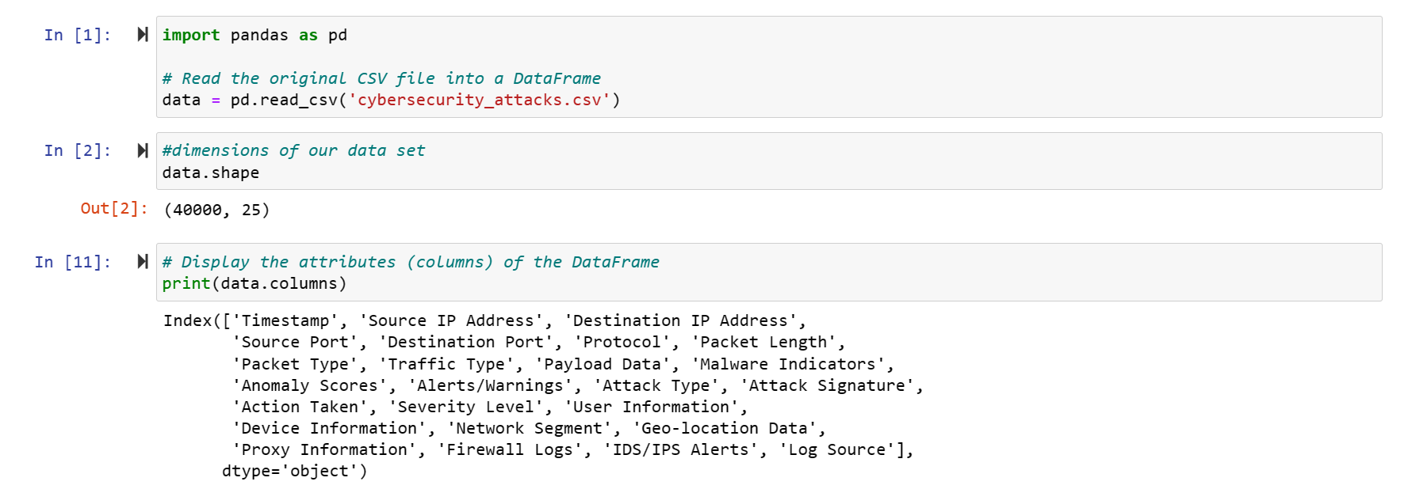
- Timestamp: is the date and time when the cyber security attack happened; the records in this data set are between 1/1/2020 and 10/31/2023.
- Source IP Address: is the originating numerical label assigned to a device on a network.
- Destination IP Address: represents the numerical label assigned to the targeted device on a network.
- Source Port: is the numerical identifier on the originating device that helps manage communication sessions.
- Destination Port: is the numerical identifier on the targeted device that designates the specific service or application receiving network traffic.
- Protocol: is a set of rules governing the format and transmission of data.
- Packet length: refers to the size of data packets transmitted over a network.
- Packet type: refers to the classification of data packets based on their specific communication protocols.
- Traffic Type: encompass various communication protocols, including DNS, FTP, HTTP, and others, each requiring analysis to detect and counteract specific threats.
- Payload Data: The actual data or content of a message or communication, excluding the headers or metadata. It is crucial for identifying malicious content, as many attacks involve the transmission of harmful payloads.
- Malware Indicators: Specific attributes or patterns associated with malicious software, serving as clues for detecting the presence of malware.
- Anomaly Scores: Numeric values assigned to deviations from normal behavior or patterns in a system or network. Anomaly scores help in highlighting unusual activities, potentially indicating a security incident or cyber attack.
- Alerts/Warnings: Notifications generated by security systems or tools to indicate potential security incidents or policy violations.
- Attack Type: refer to diverse methods and techniques employed by malicious actors, such as phishing, ransomware, and DDoS, to compromise systems, networks, or data, necessitating tailored defense strategies.
- Attack Signature: is a unique pattern or characteristic associated with a specific type of cyber threat or malware, enabling the identification and prevention of known attacks based on recognizable indicators.
- Action Taken: refers to the specific response or countermeasure implemented by security personnel or systems in response to a detected security incident or threat.
- Severity level: of a cyber attack is a classification indicating the degree of potential impact and harm caused, guiding prioritization and response efforts based on the threat's criticality.
- User Information: in the context of our data set it is the name of the user.
- Device Information: details about the targeted device, encompassing the operating system and browser used during the attack.
- Network Segment: is a distinct and isolated section of a network, often separated for security purposes.
- Geo-location Data: information indicating the physical location or origin of network traffic, aiding in the identification of potential threats based on the geographic source.
- Proxy Information: details related to proxy server activities, including requests and responses, crucial for analyzing and monitoring user web activities and detecting potential malicious behavior.
- Firewall Logs: records generated by a firewall that contain information about permitted and denied network traffic.
- IDS/IPS Alerts: notifications generated by Intrusion Detection Systems (IDS) or Intrusion Prevention Systems (IPS) in response to potentially malicious activities.
- Log Source: is the origin or system generating logs, such as firewalls, servers, or security appliances.
Tools:
- Python was used for data cleaning and feature engineering.
- Tableau was used for data visualization.
Data Cleaning:
The missing values in our dataset were determined by python using the following code.
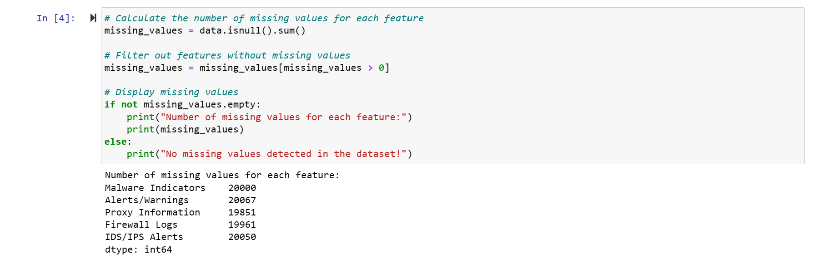
- Missing Malware Indicators are replaced by “No Detection”.
- Missing Alerts/Warnings are replaced by “no”.
- Missing Proxy Information is replaced by “No proxy”.
- Missing Firewall Logs are replaced by “No Data”.
- Missing IDS/IPS Alerts are replaced by “No Data”
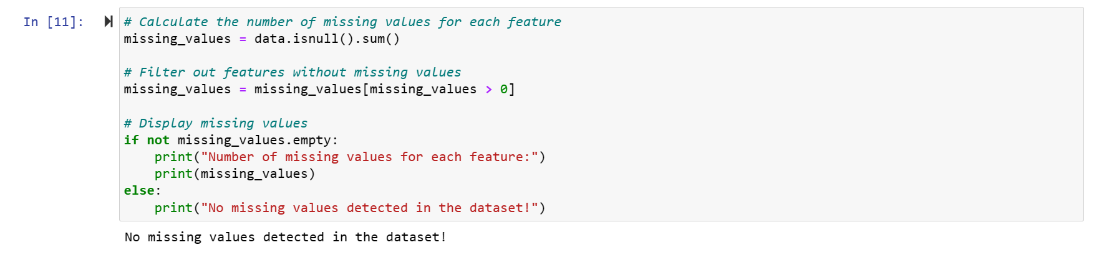

Exploratory Data Analysis
After performing the data cleaning, I rechecked my data to make sure there is no more missing data in my dataset.
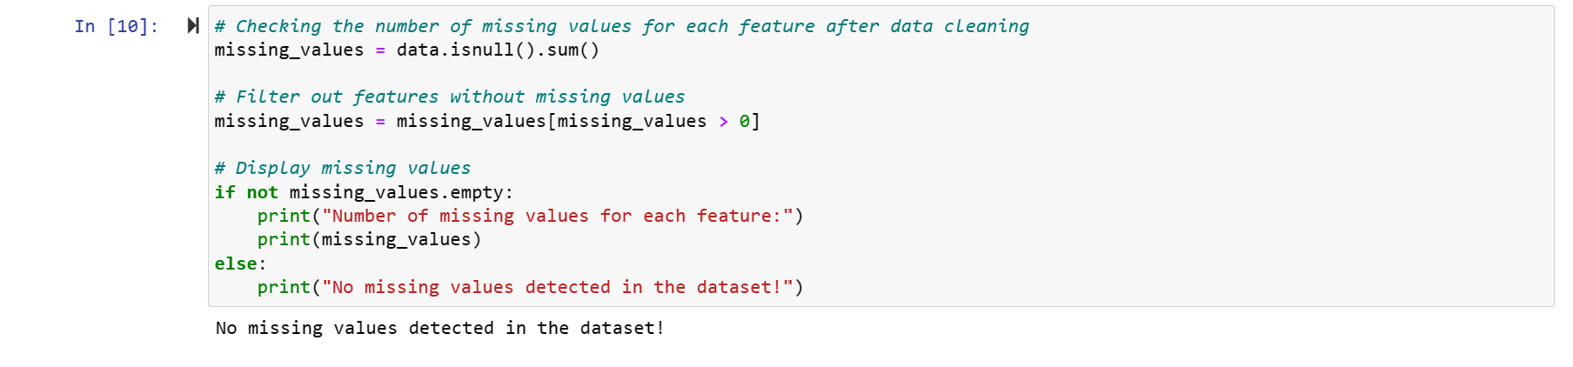

Data feature engineering.
Some of the issues that I initially faced with using the dataset in tableau:
- Geo-location Data was not recognized by tableau. I used python to split “City, State” format in the Geo-location column into a “State” and “City” columns to be able to generate map visualizations.
- Device information data was for example “Opera/8.38. (X11; Linux x86_64; pt-BR) Presto/2.9.175 Version/12.00” which has different versions of the brewers and operating systems. To have a better view of which browser and operating systems are more vulnerable to cyber attacks. I cleaned the data by creating a column for the operating system and a column or the browser that was being used at the attack incident.
- Timestamp was initially not recognized by tableau in csv type file. After splitting the timestamp into “Weekday”, “Day”, “Month” and “Year” and creating an excel workbook for the new data the time stamp was functioning in tableau. I used this data to analyze if there are any time patterns for cyber security attacks.
The code for creating the data set with new features is as follows:
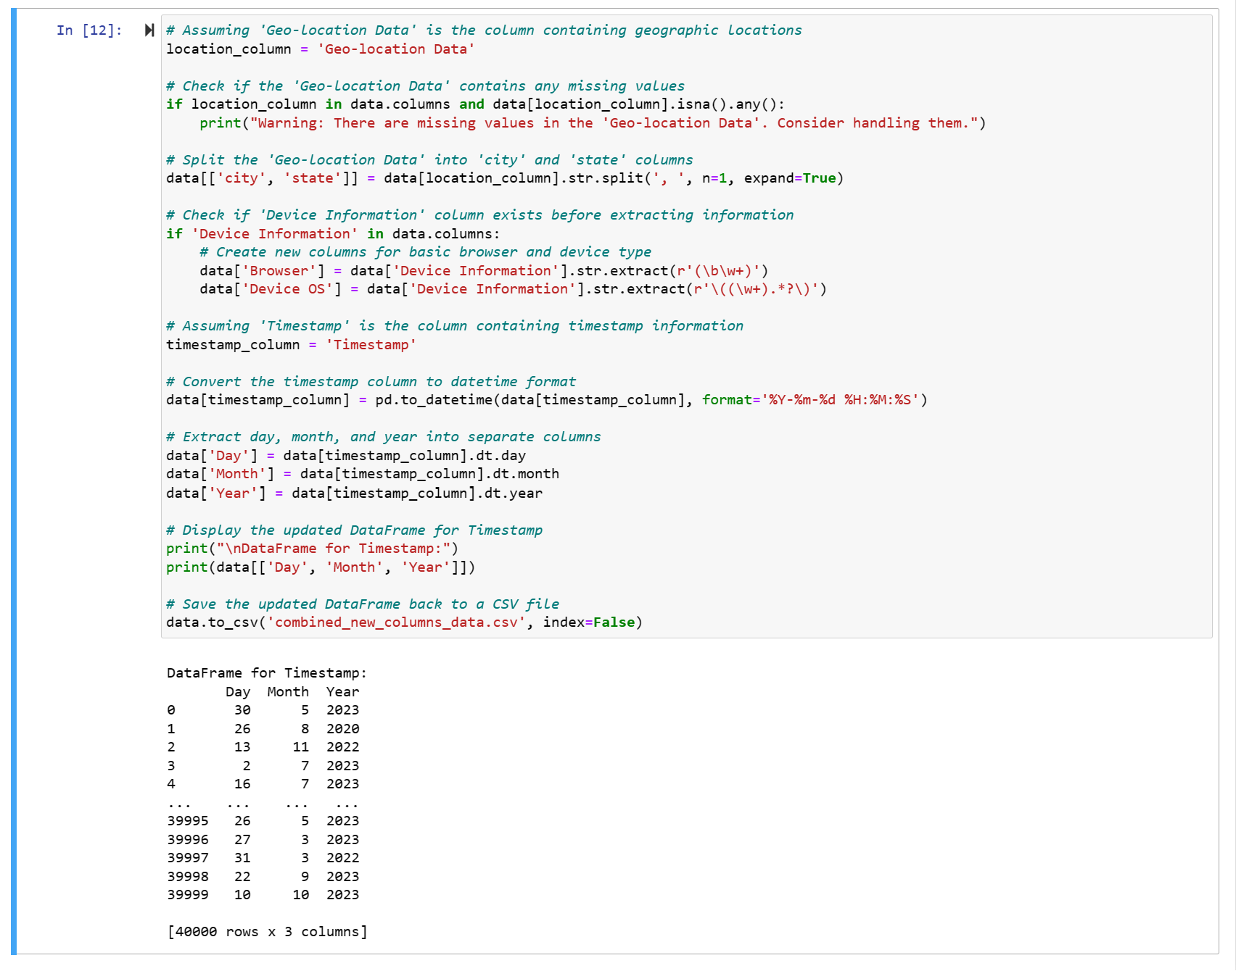
Here is a sample of the data set after cleaning:
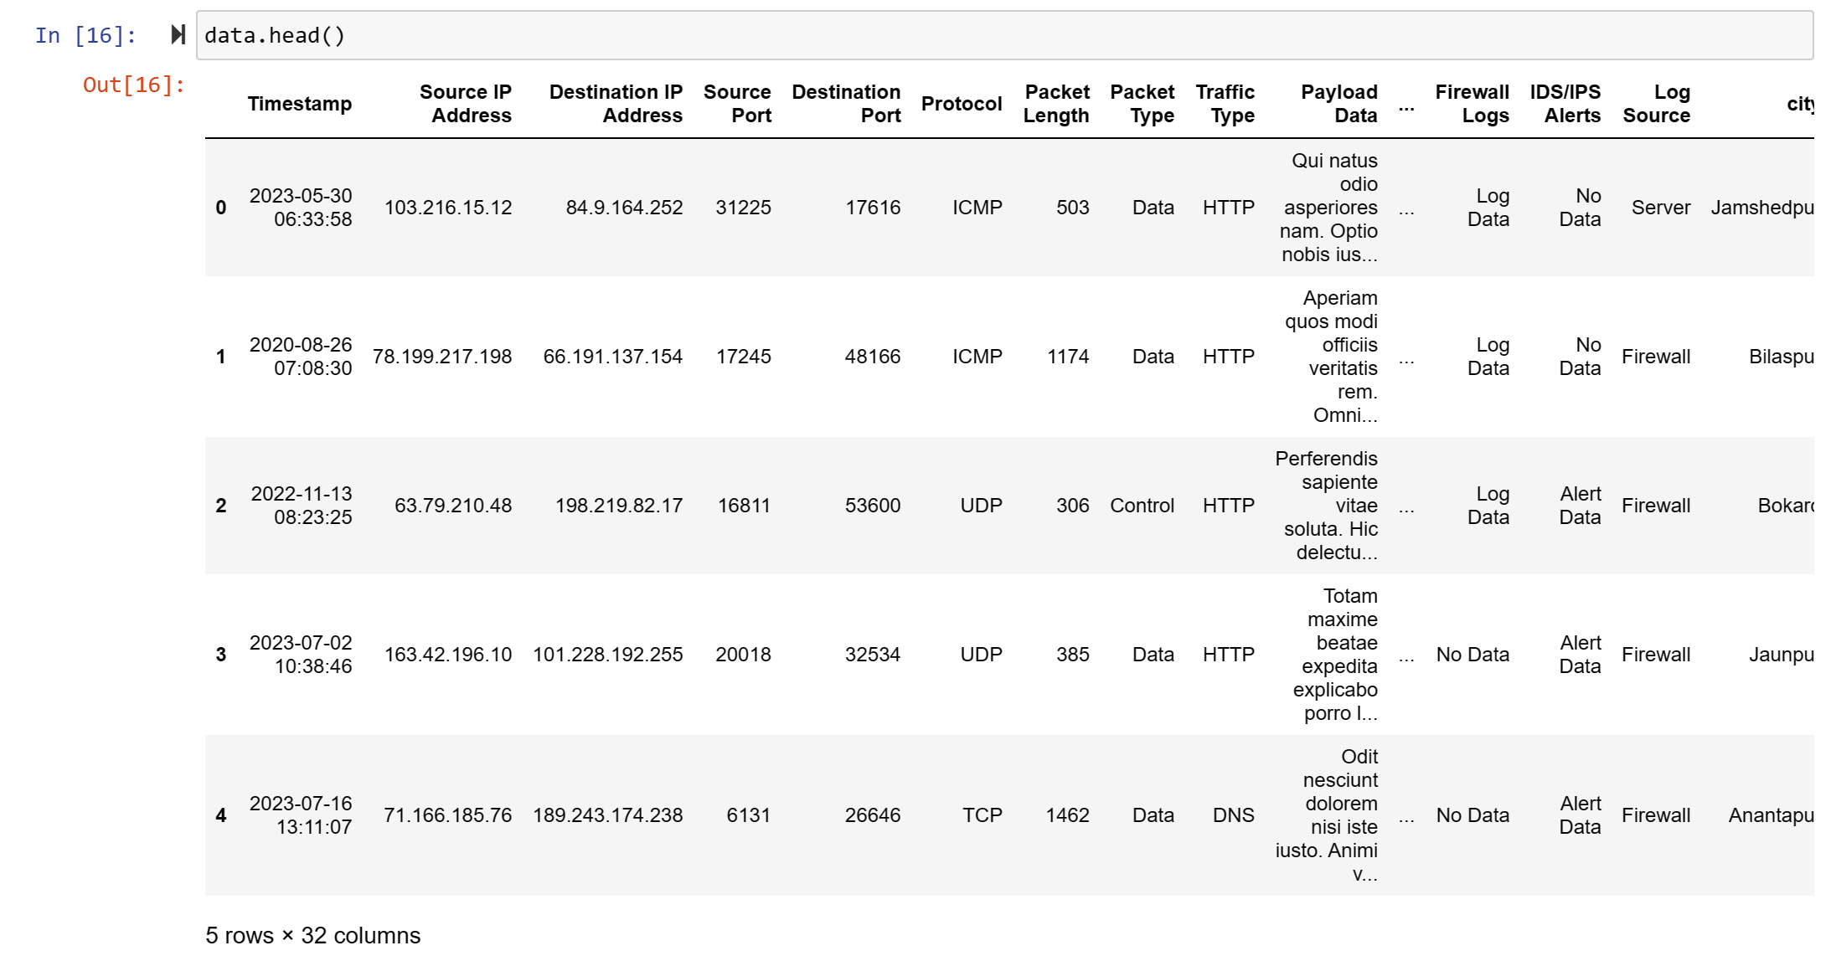
In the first part of the data exploratory analysis, we will analyze cyber attacks with respect to time.
- Which year has the highest number of cyber security attacks from 2020 to 2023? How is the trend of cyber security attacks from 2020 to 2023?
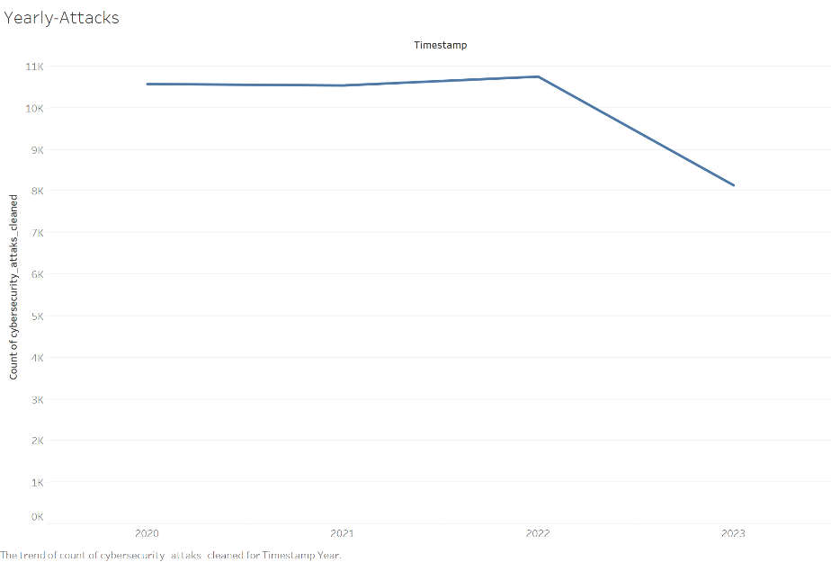
Result:
Above is a visualization that year 2022 had the highest number of cyber security attacks from 2020 to 2023 and is equal to 10,750. The trend of yearly cyber security attacks seems to be constant between the 3 years taking into consideration that we have record only for 10 months from year 2023 and there might be some records not reported yet.
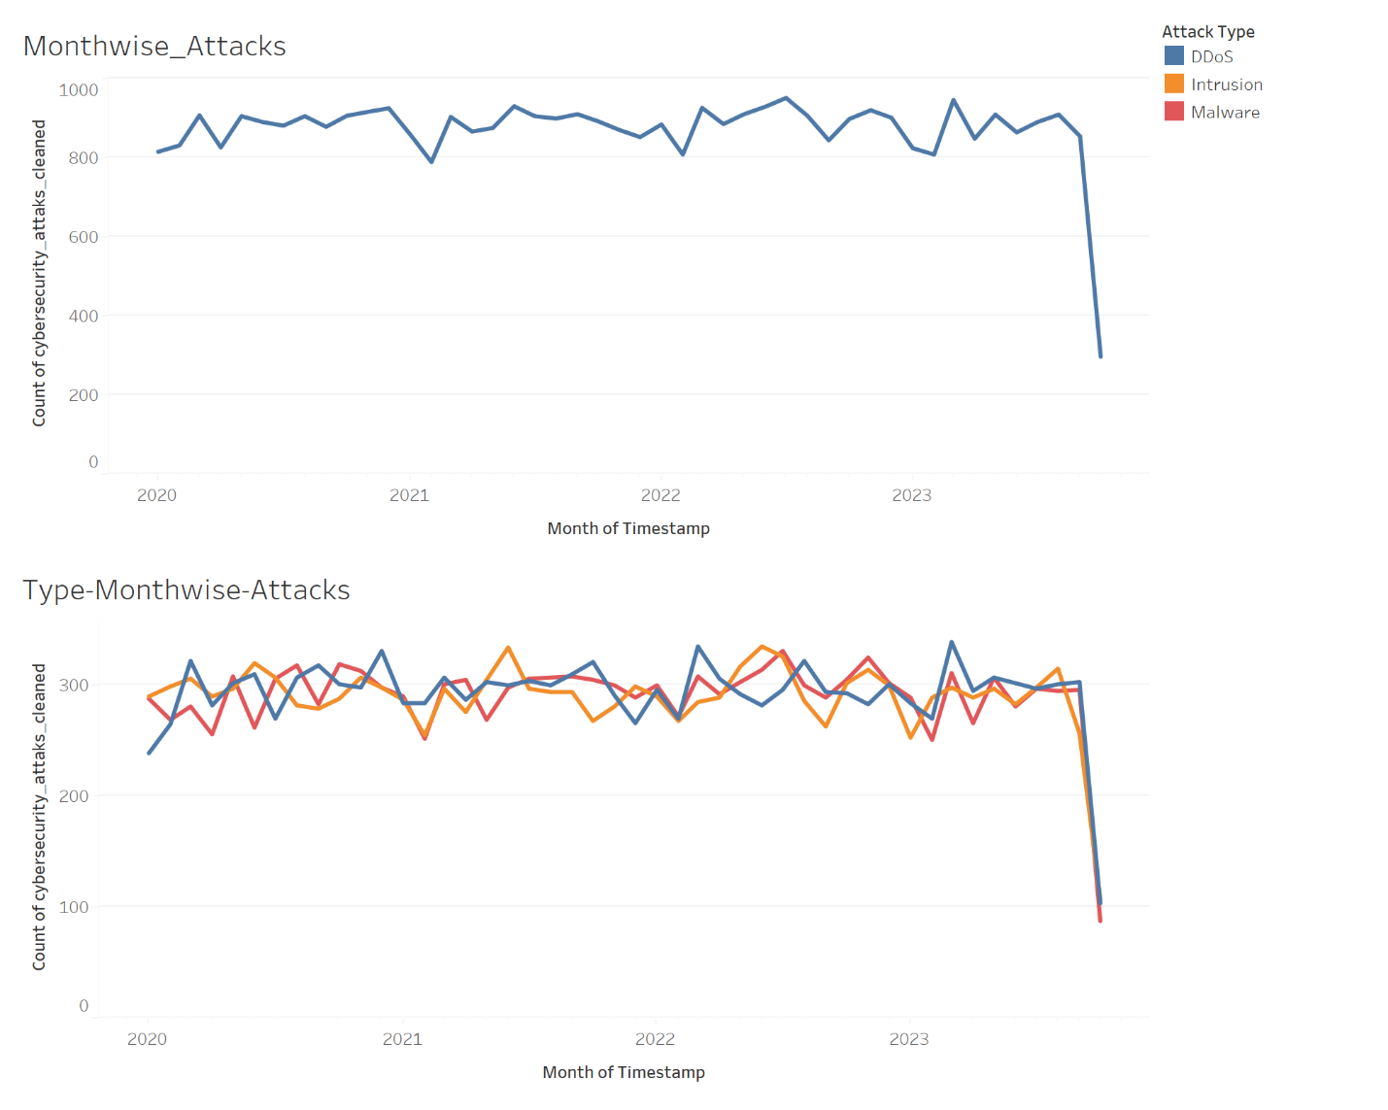
- Which month had the highest cyber security attacks from 2020 to 2023? Which type of attack had the highest attack record among all the months?
Result:
July 2022 has the highest number of cyber security attacks from January 2020 to October 2023. March 2023 had the highest record among all the attack types where the DDos attack type count was 338.

- What percentage of users were given an Alert or Warning before the cyber attack? What was the most common actions taken in response to the attack?

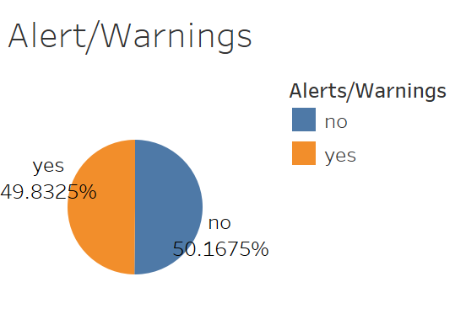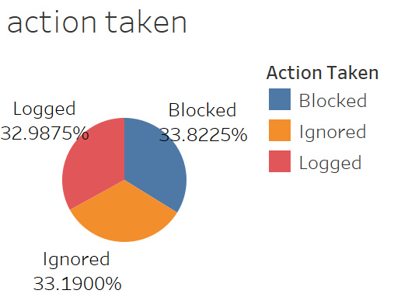

In the above visualization, 89.83% of the users received an alert or warning before the attack and 51.17% did not receive an alert or warning before the attack. The most common action was “Blocked” the attacked with 33.82% of the total actions taken.
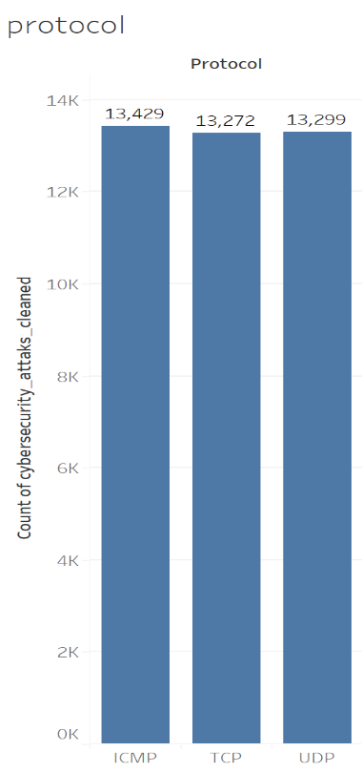
- Which protocol had the highest count of cyber security attacks?
In this visualization, one can note that ICMP had the highest count of cyber security attacks although the three protocols ICMP, TCP and UDP had close cyber attacks count.

- What Device operating system had the highest number of attacks?
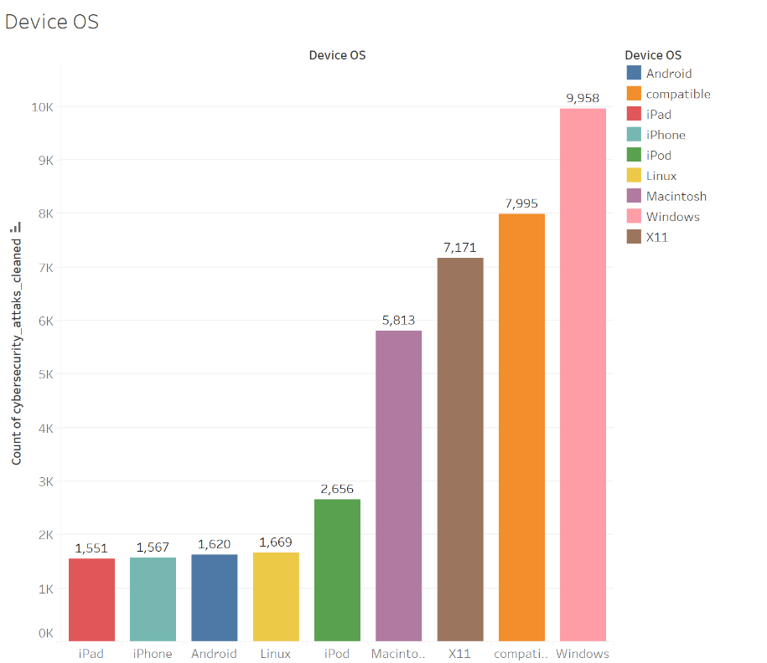
In the above visualization, one can see that windows had the highest number of cyber security attacks with number of attacks equal to 9,958.

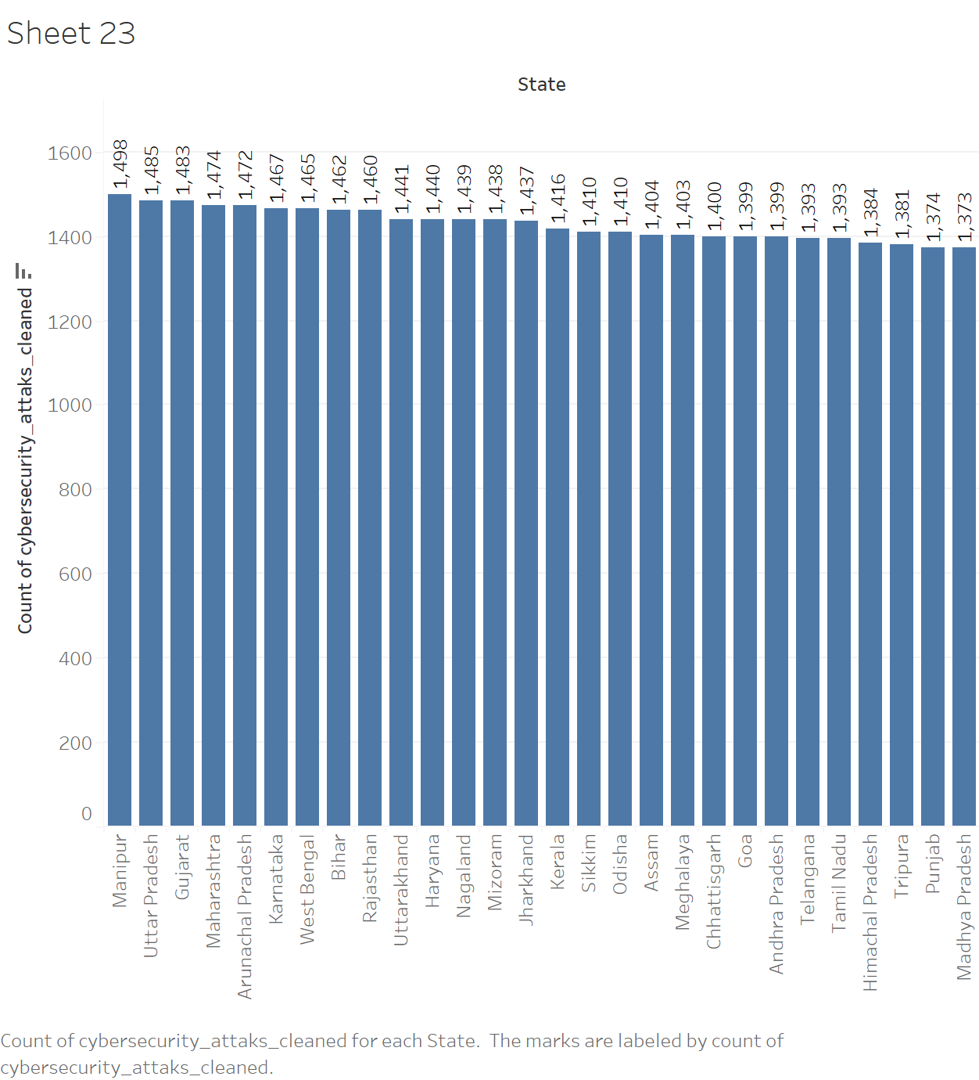

Hypotheses

Graph-Breakthrough-Result
- Geographical Map
A Geographical Map is employed for addressing spatial inquiries and analyzing data based on geographical parameters. The dataset includes latitude and longitude values to spatially represent the data on the map and generate visualizations.
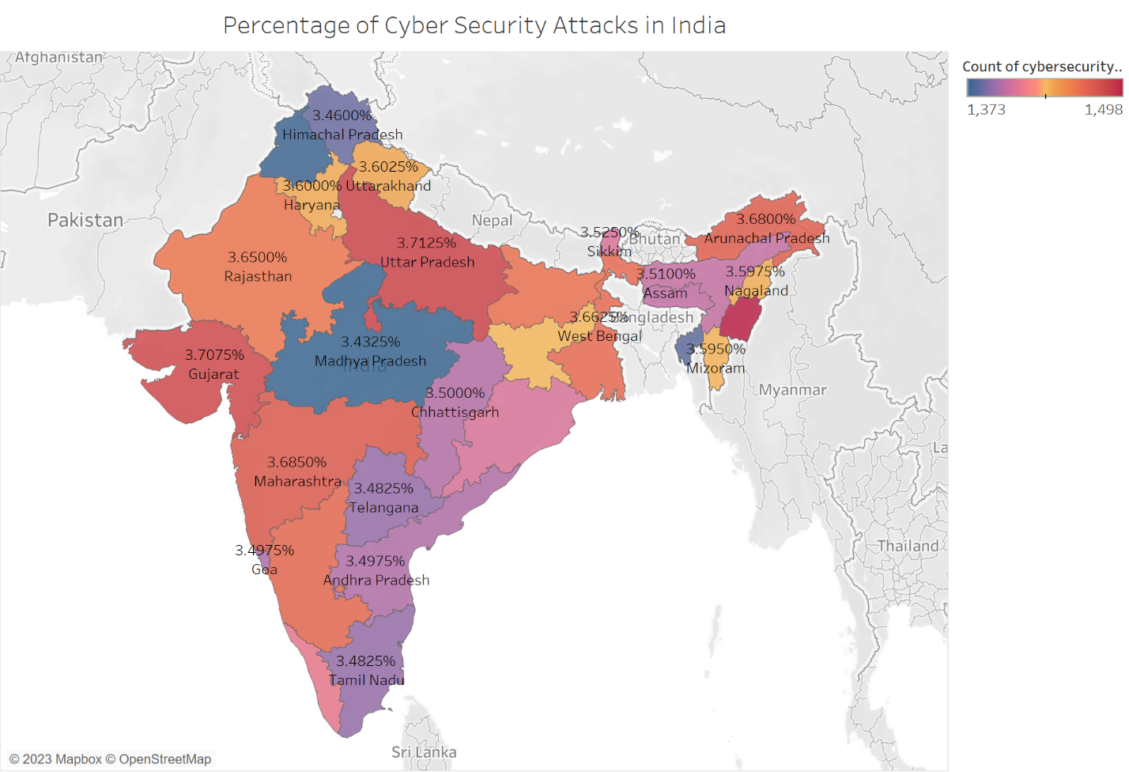
Initially, I had 28 unknowns in my map. I used the “edit location” feature in the map and changed the “country/region” to “India” instead of the United States. The map visualization is achieved by adding the “cybersecurity_attacks_cleaned count” attribute to the Text marks and changing the “Quick table calculations” to percent of total. Also, “cybersecurity_attacks_cleaned count” is added to the color marks and selected the “Sunrise-sunset diverging” for the color on the map.
Result
The above map visualizations show the percentage of the total cybersecurity attacks in each state in India. The percentage of cyber security attacks in India starts with 3.43% in Punjab and Madhya Pradesh and increases to reach its maximum percentage 3.75% in Manipur.
Below visualization is generated using the attack type attribute.

The geo-location data is presented in a 'City, State' format, but the clear association between the cities and their respective states is ambiguous. To decipher this data, I have developed a visualization aimed at identifying the primary targets of cyber attacks and discerning the locations most susceptible to successful attacks.

Horizontal bar Graph
Horizontal Bar graph is used to compare the various categories in all the dimensions.

Using tableau, the following visualization is created to find the top 10 attacked by cyber security attacks between Jan 2020 and Oct 2023.
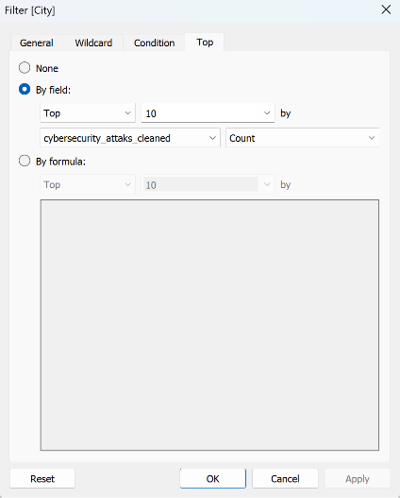
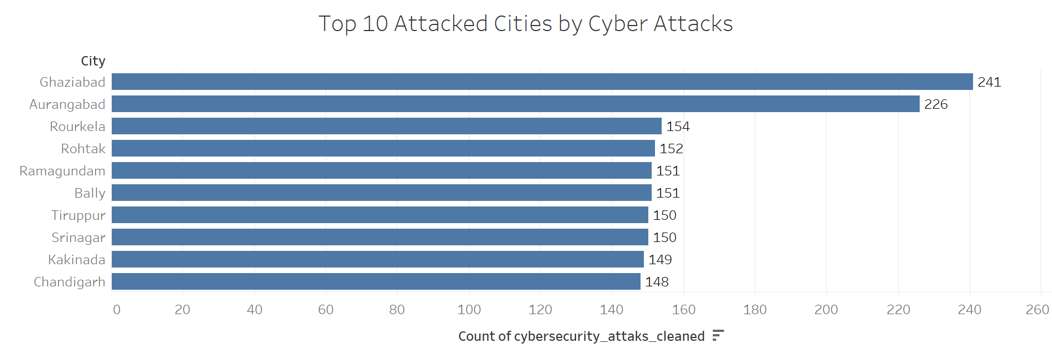

Result
Ghaziabad is the top attacked city taking into consideration it has the highest count of cybersecurity attacks. In the second place comes Aurangabad which has a close count of cybersecurity attacks to Ghaziabad.

Word Cloud
In another trial to clear the ambiguity of the Geo-location data, I created a word cloud for the Geo-location Data in python to see the words that have the highest frequency. Below the code used to generate the word cloud.

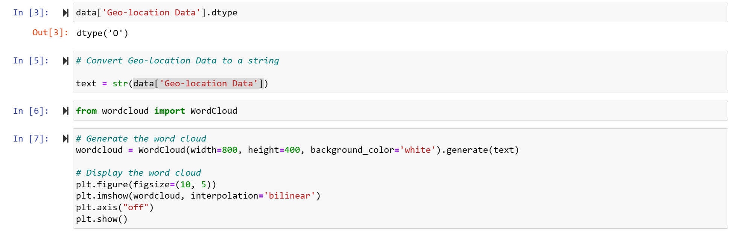

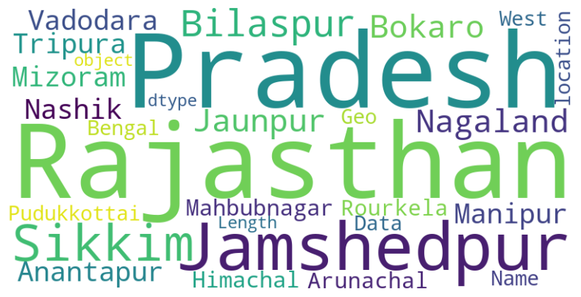
Result
Referring to the map above, one can see the word ‘Pradesh’ appears in the name of the state with the second highest percentage of attacks and it appears in the name of five states: Uttar Pradesh, Arunachal Pradesh, Himachal Pradesh, Andhra Pradesh, Madhya Pradesh. Since there is only one state containing the name ‘Rajasthan’ and it has the ninth rank among the highest targeted states, we can conclude from the word size it is frequently targeted at different timestamps. The city ‘Jamshedpur’ is the only city that appeared in this size in the word cloud which also means this city has been frequently targeted at different timestamps but it did not appear in the top 10 attacked cities.

In attempt to understand why Jamshedpur appeared in this size in the above word cloud. Using tableau, I created a word cloud of the Geo-location Data with respect to the its count and used the Filter
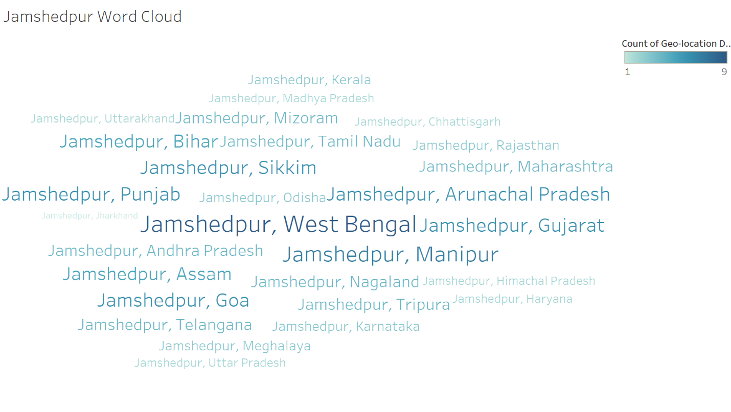
Jamshedpur appears in the biggest size in accordance with West Bengal then Manipur which are amongst the top 10 attacked states.

Using python, I detected the frequency of given Geo-location Data
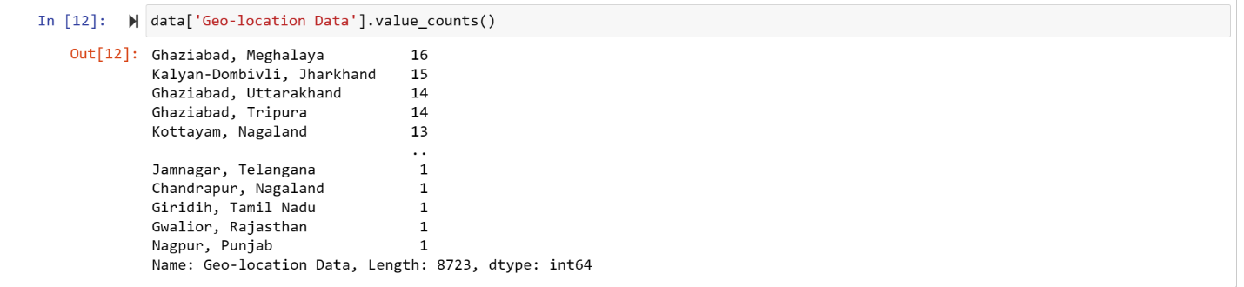
In the result, Ghaziabad city appears in 3 out of the top five frequencies of the Geo-location Data which means based on the previous observations of top attacked cities, Ghaziabad is one of the hot locations for cyber targets and attacks.
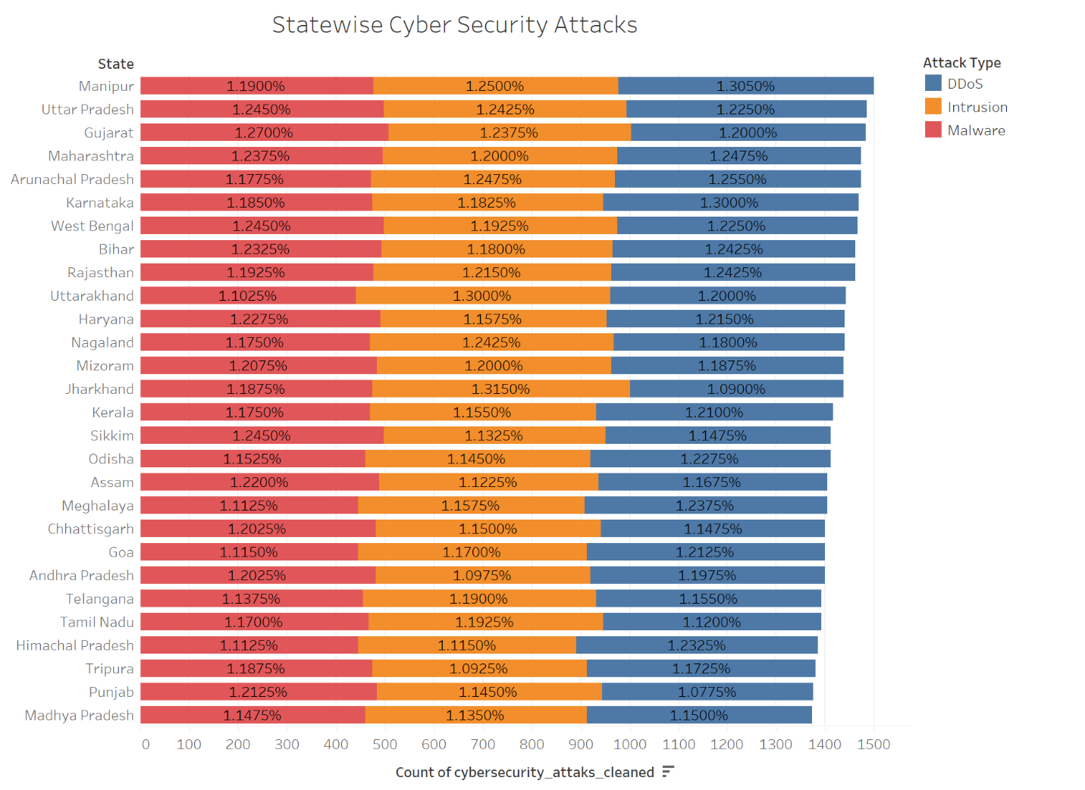

The above graph is achieved by using attributes such as “cybersecurity_attacks_cleaned count”, State, and calculated the cybersecurity_attacks_cleaned count based on the “attak type” i.e DDos, Malware, and intrusion, and change the quick table calculation to percentage of total.

Result

The graph demonstrates that under all the attack types the percentage of each attack type in one state was very close. Taking into consideration all the states the percentage of each attack type was very close as well. One may conclude that there is no significant effect for the attack type on the count of cybersecurity attacks.

Below visualization is generated using the attack type attribute.

Box-and-Wisker plot
The advantage of using box-and-whisker graphs, also known as box, plots, lies in their ability to provide a concise visual summary of the distribution of a dataset, including measures of central tendency, variability, and the presence of outliers. Box-and-whisker plots offer a clear representation of the median, quartiles, and the spread of the data, making it easier to compare and analyze distributions across different groups or variables. They are particularly useful for identifying the skewness, symmetry, and overall shape of a dataset, aiding in effective data interpretation and decision-making.
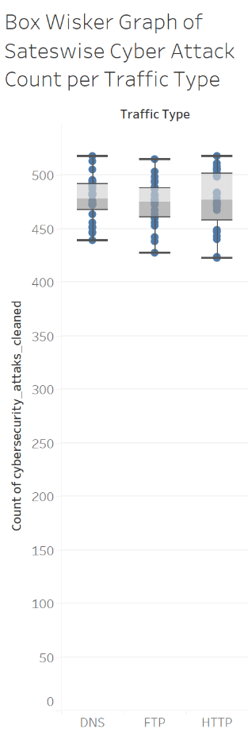
The traffic type data in a box-and-whisker plot are close to each other. This means that dataset has low variability or dispersion. In other words, the values in the dataset are relatively consistent and do not deviate significantly from the central tendency measures, such as the median. The interquartile range (IQR), represented by the length of the box in the box plot, is a measure of the spread of the middle 50% of the data. A smaller IQR indicates that most of the data points fall within a narrow range. The components of the box-and-whisker plot imply:
1. Box (interquartile range): The length is relatively short, indicating that the central portion of the traffic type data is tightly clustered.
2. Whiskers: The whiskers may also be short, suggesting that the values outside the central region (potential outliers) are not significantly distant from the bulk of the data.
This closeness in the components of the box-and-whisker plot implies a more consistent and uniform distribution of the dataset, with less variability among the data points.

Device Information Analysis



